

WSIX PM PROCEDURE
PM Type: YPM Prepared by:
Machine: WSIX CVD Robin 羅彬森
PM Frequency: 20000 to 22000 wafer S200 FURNACE
Date: May 2017

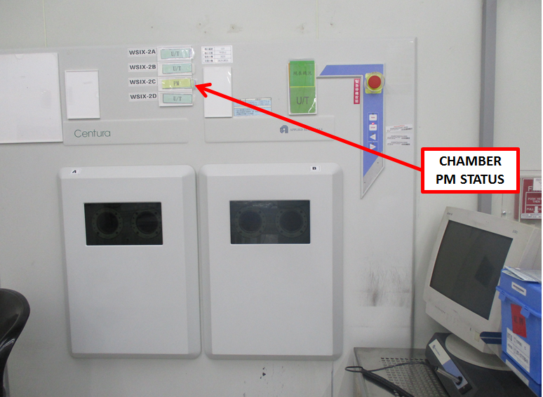 |  | 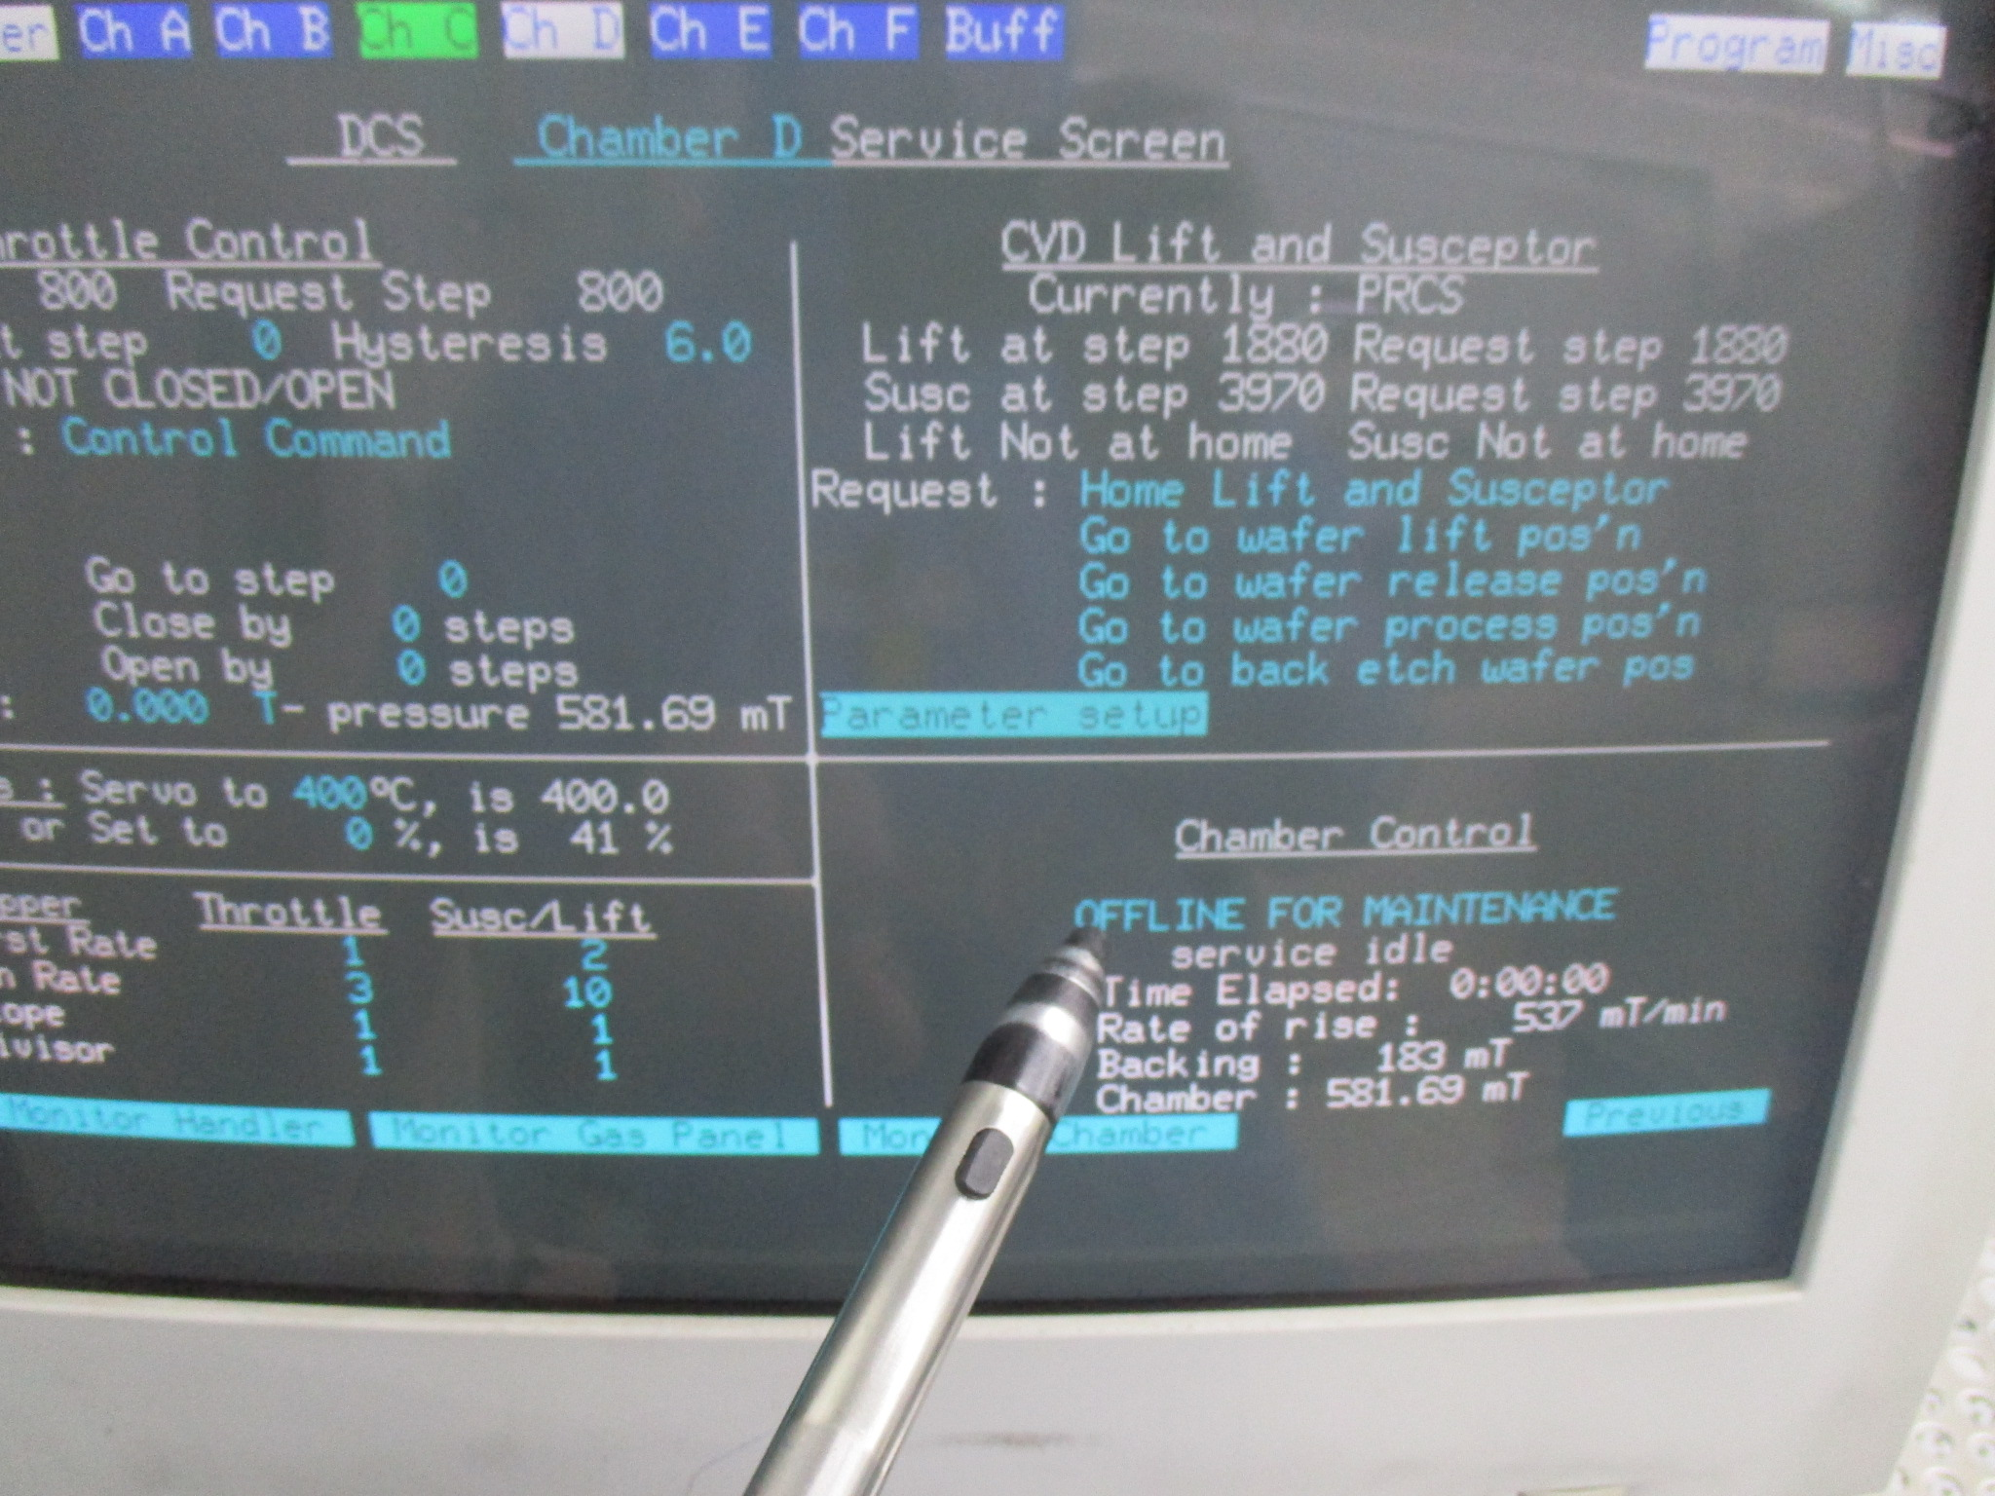 |  | 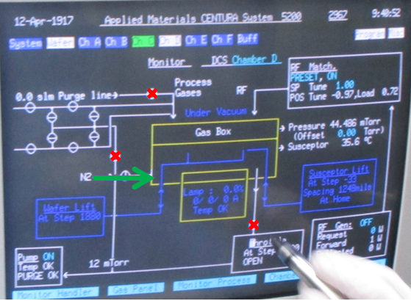
- Confirm if chamber is ready to PM, (No wafer process inside) |  | - Confirm if slit valve closed than Set chamber service to OFFLINE for Maintenance, |  | - Turn off throttle valve and AR gas supply and vent chamber

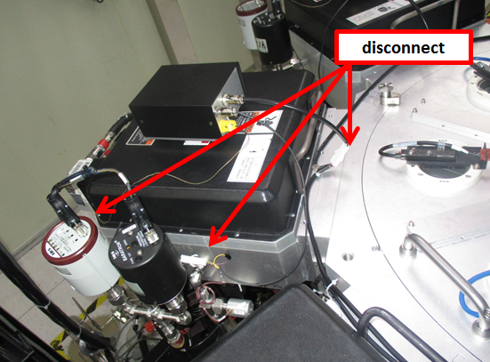 |  | 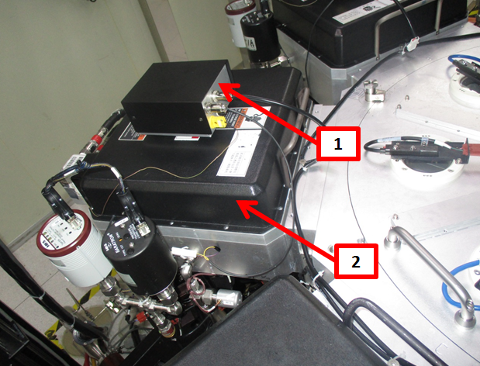 |  | 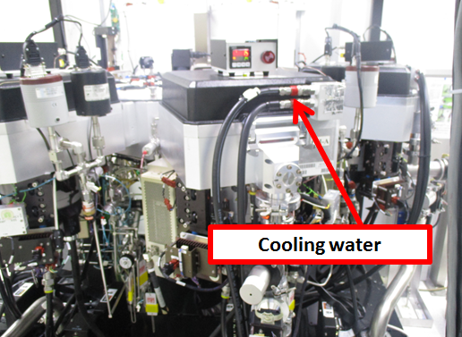
- Remove heater connection, and TC cable wire |  | - Remove TC monitor and top cover |  | - Remove chamber lid cooling water hose connection

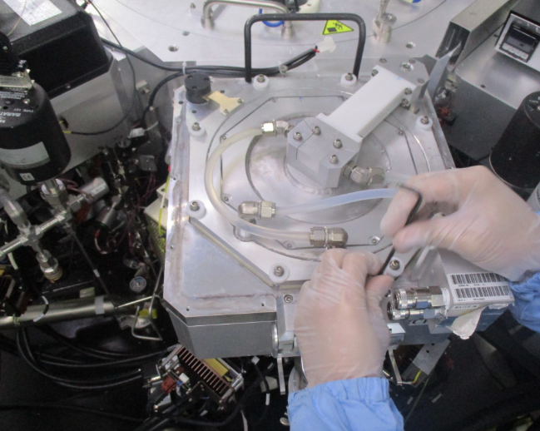 |  | 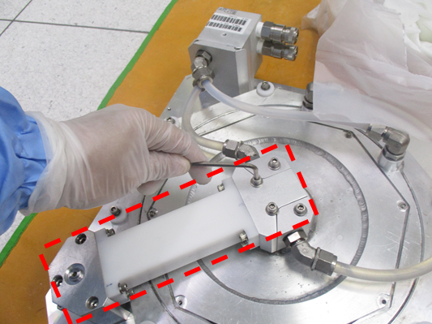 |  | 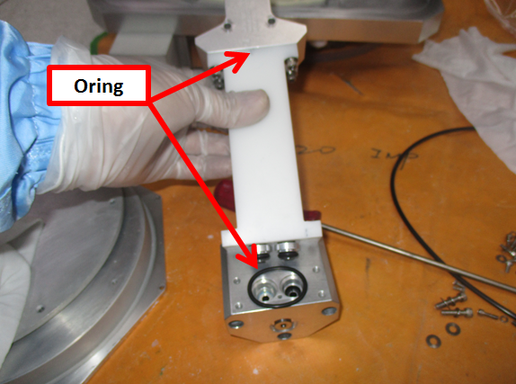
- remove chamber (3screw) and takeout chamber lid |  | - On chamber Lid, remove gas feed line assembly, |  | - Disassemble gas feed pipe to clean inside

Doc. #: 2017-CRP-009 rev.00 Page 1 of 4

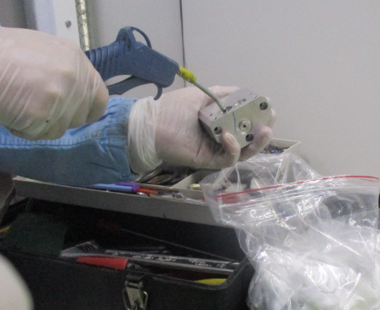 |  | 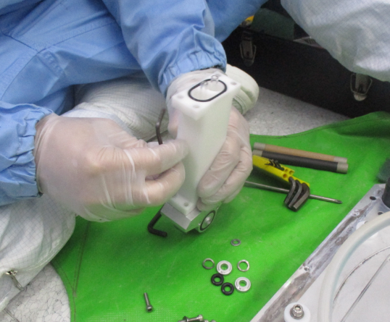 |  | 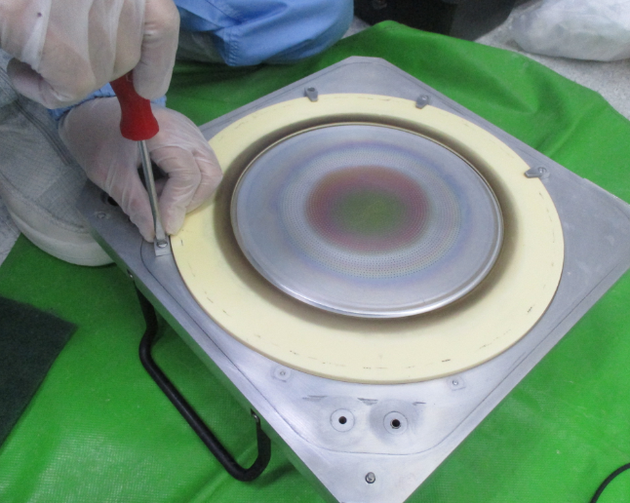
- Clean inside manifold part using pressured air |  | - Change all o ring and change quarts tube pipe |  | - Remove shower head assembly

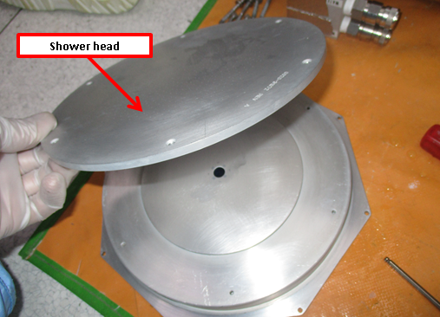 |  | 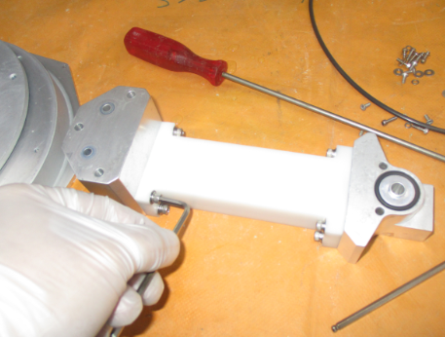 |  | 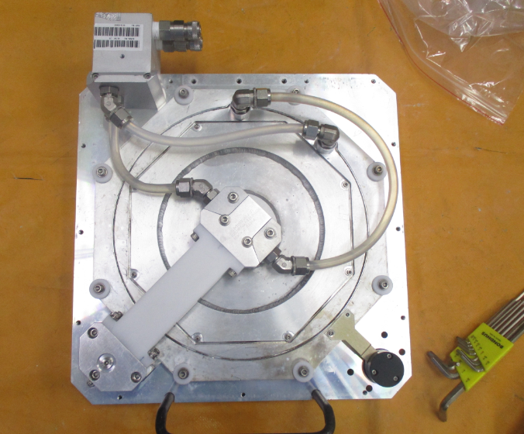
- clean shower head then clean by IPA and pressured air TOP and BOTTOM |  | - Assemble and install clean gas feed pipe |  | - Clean and assemble chamber lid with shower head and gas feed assembly. Change all O-ring

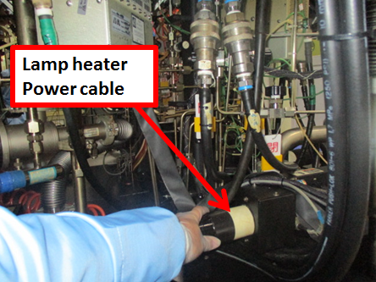 |  | 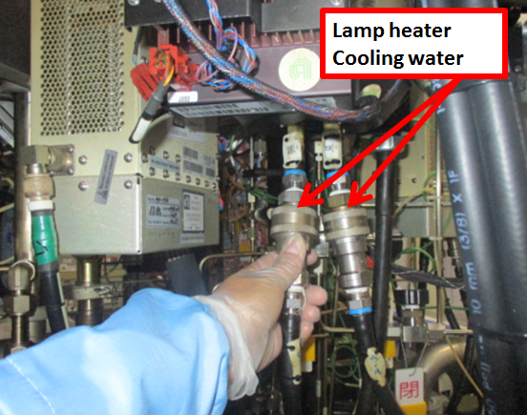 |  | 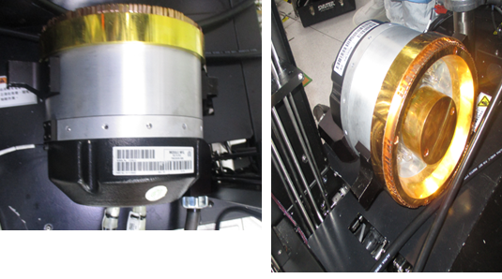
- Remove lamp heater power cable |  | - Remove lamp heater cooling water supply |  | - Remove Lamp heater module

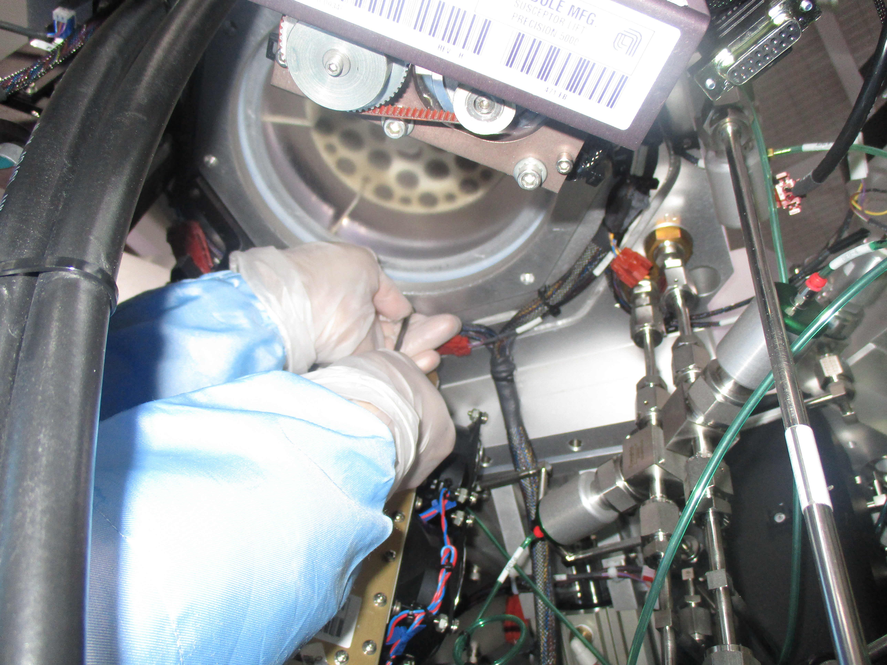 |  | 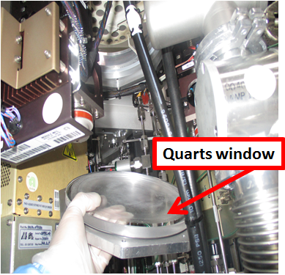 |  | 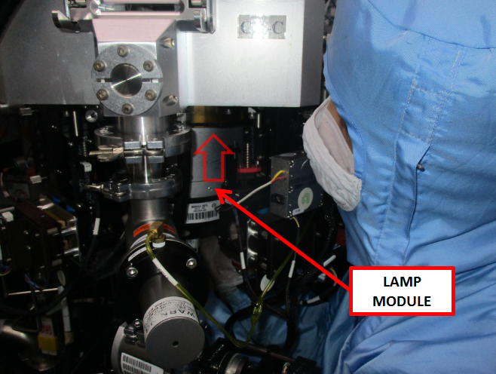
- Remove quarts window, 8screw |  | - Install new/clean quarts window using new o ring |  | - Install Lamp heater module

Doc. #: 2017-CRP-009 rev.00 Page 2 of 4

 |  |  |  | 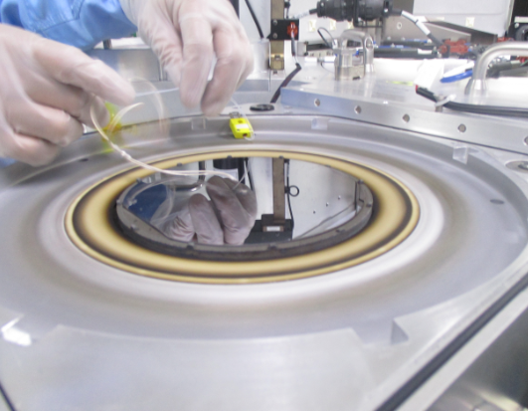
- Connect chamber cooling water supply |  | - Connect lamp heater and power cable |  | - Install chamber lid and put TC wafer on suscepter (wafer process position

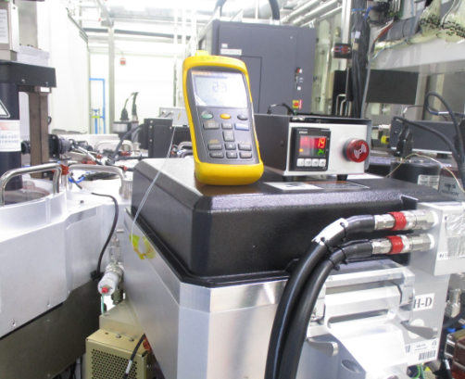 |  | 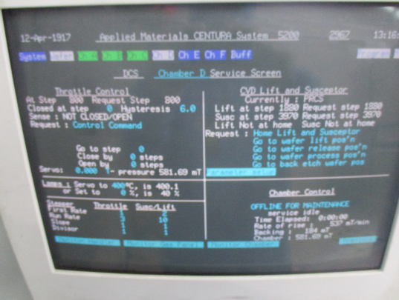 |  | 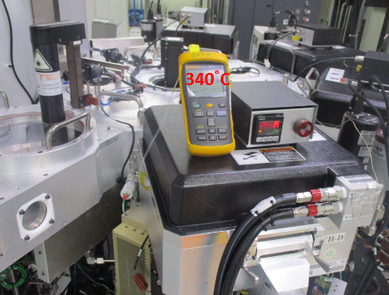
- Close chamber and connect temperature meter |  | - Pump down vacuum and heat up to 400 degrees |  | - Check and adjust and check reading until TC wafer Temperature reading reach 340degC

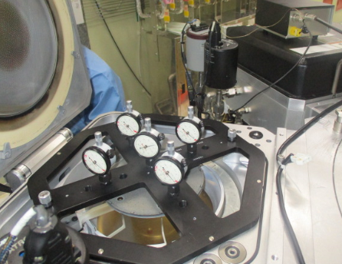 |  | 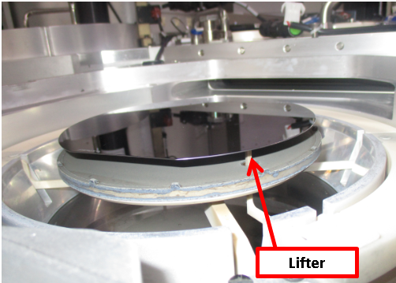 |  | 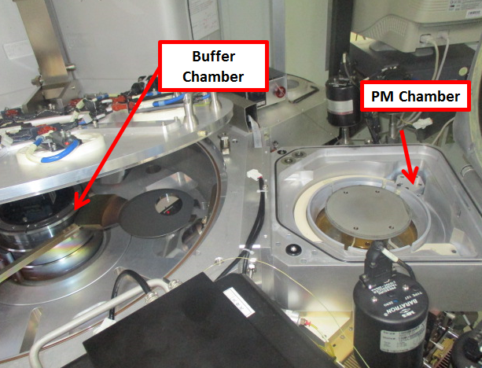
- Cool down chamber, open and check horizontal level of suscepter. Adjust if needed |  | - Move up lifter, put dummy wafer on top and check horizontal level. all finger position must touch wafer |  | - Open buffer chamber to check transfer

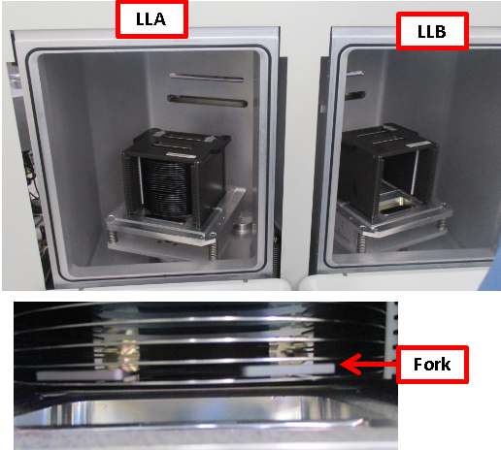 |  | 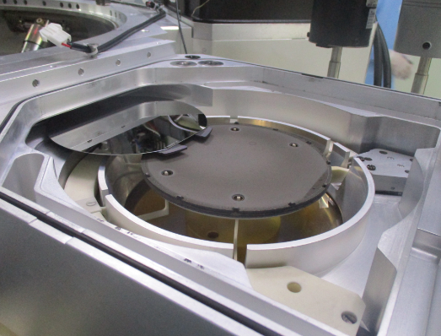 |  | 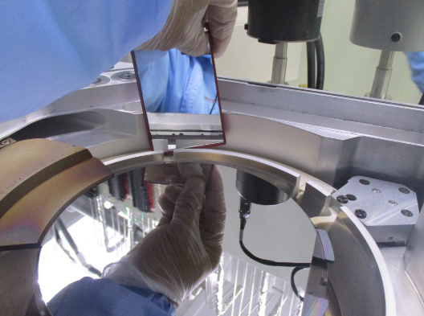
31. Remove dummy on chamber. Transfer check by loading cassette of dummy wafer from Load lock A and B |  | 32. Check and watch transfer robot position 1 by 1 step to each chamber |  | 33. Check transfer if height of wafer do not touch chamber lifter
Doc. #: 2017-CRP-009 rev.00 Page 3 of 4

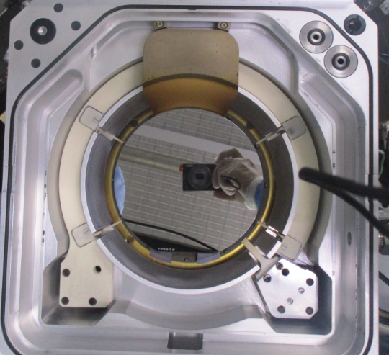 |  | 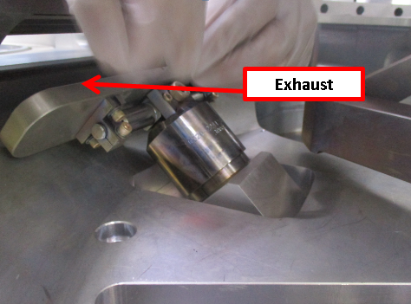 |  | 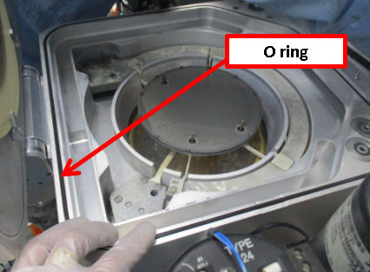
34. Do wafer transfer to chamber then check and adjust wafer position to center of susceptor. |  | 35. Transfer Ok, change slit valve O ring |  | 36. Change chamber lid O ring clean inside and close chamber

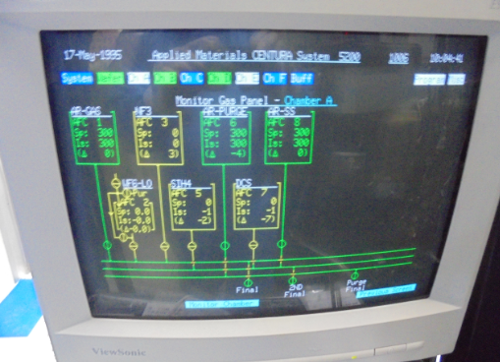 |  | 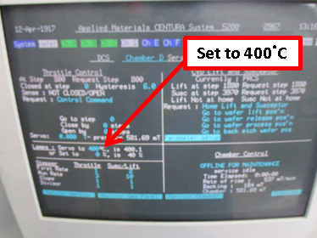 |  | 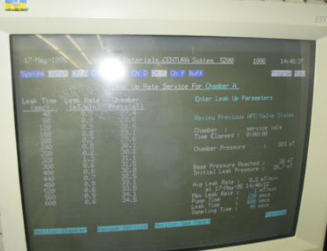
37. Close chamber pump Vacuum and purge AR gas |  | 38. set heat up to 400degC |  | 39. Conduct leak check average of <0.8mTorr/min

EA TEST RUN
40. Inform EA for test run and PTC inspection

Doc. #: 2017-CRP-009 rev.00 Page 4 of 4

